Knopf-Uhr

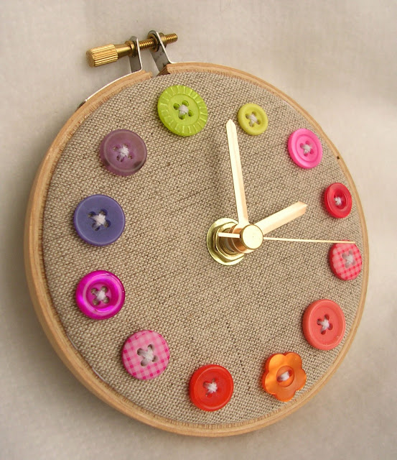

http://www.filabro.ch/holz-stickrahmen-rund.html

http://createc.ch/bin/srves.exe/loadHTML?file=group_reload.htm&UID=127019_113A310AA122&$info?partno=80.1973&zzz=Quarz-Uhrwerk%2C+51+x+31+x+15+mm%2C+16.2+mm+Achsl%E4nge&UID=0_10

